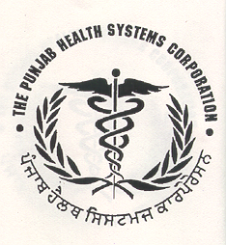
PUNJAB HEALTH SYSTEMS CORPORATION
E-Block, 2nd Floor, Phase-8, (Sector 62)
Punjab School Education Board Complex
Sahibzada Ajit Singh Nagar (Mohali), PUNJAB
Phone: 0172- 2232245 & 2232247
Visit us at: phsc.punjab.gov.in:
E-mail: proc.directorphsc@gmail.com , procmedicinephsc@gmail.com

Bid Ref No. PHSC/Proc/2022/AAC

ADDENDUM

A notice inviting quotations was published in the newspapers for procurement of following medicines.

Sr. No. | Name of the Medicine | Qty | EMD ( In Rs) | Delivery period
1 | Tab Nifedipine10mg | 15000 tablets | 1000.00 | Immediately within 4 days
2 | Syrup Phenytion Sodium 125mg/5ml, 100 ml bottle | 3600 bottles | 4000.00
3 | Tab.Ornidazole 500 mg | 220000 tablets | 4000.00

The last date for submission of quotations has been extended till 03.08.2022 upr 11:30 am.

Corrigendum/Addendum if any will only be published on website : www. phsc.punjab.gov.in.

